

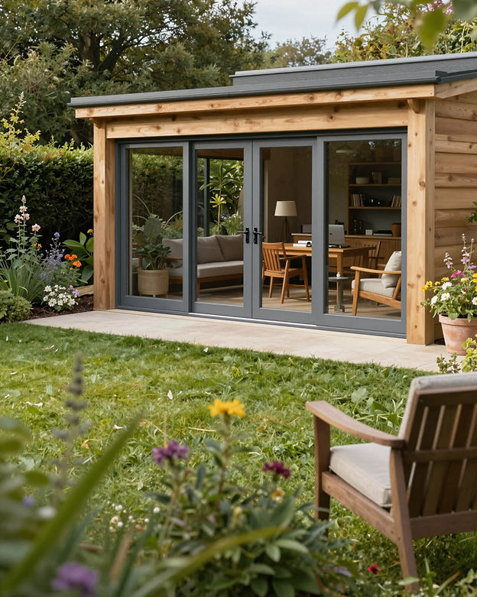

YOUR GARDEN HAS MORE TO GIVE.

Luxury Garden Rooms by Rural Landscapes Ltd
Not every home needs an extension.
Sometimes, the perfect room is waiting to be built just a few steps from your back door.
Imagine opening the doors to your own private office every morning. A peaceful gym without queues or memberships. A stylish entertaining space where friends gather long after the sun has gone down. A quiet retreat where you can switch off from the world.
A bespoke garden room doesn't just give you more space—it changes the way you live.

THE ROOM THAT CHANGES EVERYTHING
There comes a point when every home starts to feel a little smaller than it once did.
The spare bedroom becomes an office. The dining table becomes a workstation. The garage fills with storage instead of possibility.
Moving home is expensive.
Building an extension can be disruptive.
A bespoke garden room offers a smarter alternative.
Positioned within your garden yet completely separate from your home, it provides valuable additional living space without sacrificing the comfort of the house you already love.
It's somewhere to focus without distractions.
Somewhere to relax without interruption.
Somewhere that's entirely yours.
Every garden room we build is designed around the people who'll use it. Whether you're creating a productive workspace, a family entertainment room, a luxury home gym or a peaceful retreat, we'll design every detail to suit your lifestyle today while ensuring it remains flexible for tomorrow.
Built using premium insulated construction methods and high-quality materials, our garden rooms are comfortable throughout the year, making them every bit as usable in January as they are in July.
More than simply adding another building to your garden, you're creating an entirely new way of living within your home.

ONE SPACE. ENDLESS POSSIBILITIES.
One of the greatest advantages of a bespoke garden room is its ability to evolve with you.
The way you live today may not be the way you live in five years' time. That's why every building we create is designed to be as flexible as it is beautiful.
Today it could be a quiet home office where productivity replaces commuting.
Tomorrow it could become a private gym, allowing you to exercise whenever it suits you.
As your family grows, it could provide teenagers with their own space, become a stylish cinema room, a creative studio, a music room or somewhere guests can stay in comfort.
Many of our customers simply want a place to escape.
A comfortable chair.
A coffee.
A book.
A room surrounded by the garden instead of overlooking it.
Others imagine throwing open the sliding doors on a summer evening while family and friends gather for food, drinks and conversation.
There is no right answer.
The best garden room is the one that's designed around your life.
Whatever your vision, Rural Landscapes Ltd will help transform an unused corner of your garden into the room you'll wonder how you ever lived without

DESIGNED AROUND YOU

Every Garden Room Begins with Your Vision
The finest garden rooms don't start with timber or concrete—they start with a conversation.
Before we design anything, we take the time to understand how you want to live in your new space. Whether you're looking for a quiet office, a stylish entertaining area or a place to simply unwind, every decision we make is based around creating a room that works perfectly for you.
Because every home is different, every garden room we build is completely bespoke.
From the size and layout to the position of the windows and doors, every detail is carefully considered to maximise natural light, privacy and the connection between your home and your garden.
Choose from contemporary composite cladding, natural timber finishes or modern rendered exteriors. Add aluminium bi-fold or sliding doors, floor-to-ceiling glazing, feature lighting, internal storage and luxury flooring to create a space that's uniquely yours.
The result isn't just another building.
It's a room that feels like it has always belonged

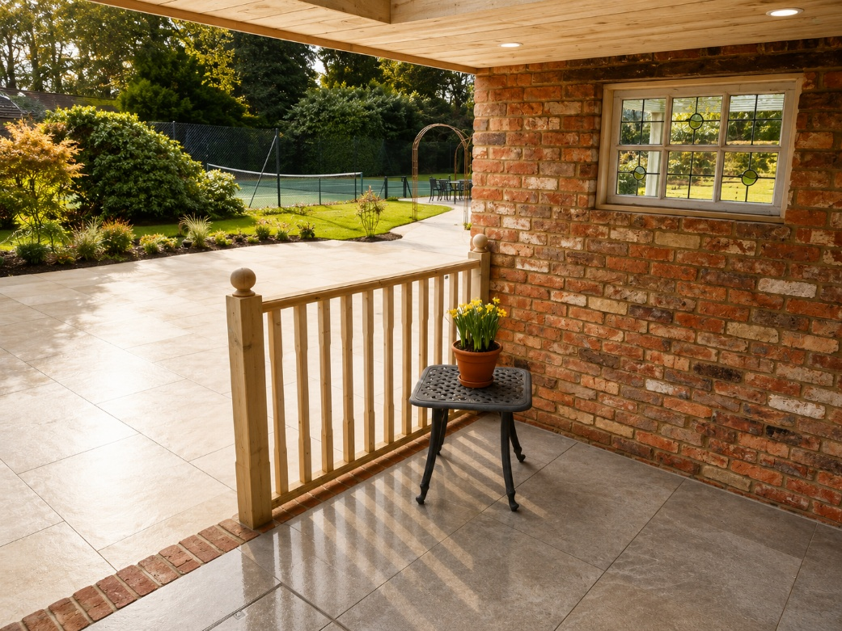

BUILT TO LAST

What's Beneath the Surface Matters Just as Much
Beautiful design means very little without exceptional construction.
At Rural Landscapes Ltd, we believe every garden room should be built with the same care and attention as your home. That's why we never take shortcuts during construction.
Every project begins with careful site preparation before installing a solid foundation that's appropriate for your garden and ground conditions.
From there, we construct a robust timber framework using quality structural timber, ensuring strength, stability and long-term performance.
High-performance insulation is installed throughout the floor, walls and roof to create a comfortable internal environment that's warm during winter and cool throughout the summer.
A breathable building membrane, quality external cladding and durable roofing system protect your investment from the British weather, while modern double-glazed windows and doors maximise energy efficiency and natural light.
Inside, every room is finished with the same attention to detail.
Plastered walls.
Quality flooring.
Modern electrics.
Stylish lighting.
Heating.
Power sockets exactly where you need them.
Every element works together to create a space that's built for everyday living—not occasional use

FROM EMPTY GARDEN TO EXTRAORDINARY SPACE

Our Installation Process
We believe the experience of having a garden room installed should be every bit as enjoyable as owning one.
That's why we've developed a straightforward process that keeps you informed from beginning to end.

Step One – Consultation
We visit your property, discuss your ideas and help you explore the possibilities.

Step Two – Design
Working closely with you, we create a bespoke design tailored to your lifestyle, budget and available space.

Step Three – Preparation
The site is carefully prepared before construction begins, ensuring solid foundations for the building.

Step Four – Construction
Your garden room takes shape using premium materials and skilled craftsmanship, with every stage completed to our exacting standards.

Step Five – Internal Fit-Out
Electrical installation, insulation, plastering, flooring and finishing touches transform the structure into a beautiful living space.

Step Six – Handover
Once complete, we carry out a final inspection to ensure every detail meets our high standards before handing over your new garden room.
Professional.
Organised.
Stress-free.
Exactly as it should be

MAKE IT YOUR OWN

Luxury Comes from The Details
The most memorable spaces are always personal.
That's why every Rural Landscapes garden room can be customised to reflect your style and the way you intend to use it.
Popular upgrades include:
• Contemporary composite cladding
• Cedar timber finishes
• Anthracite aluminium doors and windows
• Bi-fold or sliding doors
• Feature lighting
• Luxury vinyl flooring
• Media walls
• Air conditioning
• Electric heating
• Built-in storage
• Acoustic insulation
• Exterior decking
• Composite steps
• Pergolas
• Integrated planting
Whether your taste is clean and contemporary or warm and traditional, we'll help create a space that's both beautiful and practical.
Because no one should settle for an off-the-shelf garden room

INVESTING IN YOUR HOME

Guide Prices
Every garden room is individually designed, meaning no two projects are ever identical.
The final investment depends on the overall size, specification, glazing options, internal finishes and site conditions.
As a general guide:
Small Garden Rooms
Ideal for home offices and studios.
From approximately £18,000

Medium Garden Rooms
Perfect for home gyms, family rooms and entertainment spaces.
From approximately £25,000

Large Garden Rooms
Luxury multi-purpose spaces designed for year-round living.
From approximately £35,000+

FREQUENTLY ASKED QUESTIONS

Can I use my garden room all year round?
Yes. Every garden room is fully insulated and designed for comfortable use throughout every season. Combined with quality glazing and heating, your room remains warm during winter and comfortable during summer.Do I need planning permission?
Many garden rooms can be built under permitted development, although this depends on the size, height and location of the building. We'll discuss this during your consultation and advise you if permission is likely to be required.How long does installation take?
Most garden rooms are completed within 3–6 weeks, depending on the size, specification and weather conditions.Can I have a toilet or kitchenette?
Yes. We can design your garden room to include plumbing, kitchen units, sinks or WC facilities where practical and required.Can I choose my own finishes?
Absolutely.
Every project is bespoke, allowing you to choose the external cladding, doors, windows, flooring, lighting, colours and internal finishes.Will it add value to my property?
A professionally built garden room can make your home more attractive to future buyers while providing valuable additional living space for your own family.Do you provide a free quotation?
Yes.
Every project begins with a free site survey, design consultation and detailed written quotation with no obligation

WHY HOMEOWNERS CHOOSE RURAL LANDSCAPES LTD
Choosing a company to build your garden room is about far more than comparing prices.
It's about trust.
It's about quality.
It's about knowing the people you choose will care about your project as much as you do.
At Rural Landscapes Ltd, we've built our reputation by delivering exceptional workmanship, honest advice and outstanding customer service.
We don't believe in high-pressure sales.
We don't believe in cutting corners.
We believe in building every garden room as though it were for our own home.

Why Choose Us?
✔ Completely bespoke designs
✔ Premium construction materials
✔ Fully insulated for year-round use
✔ High-quality doors and glazing
✔ Experienced professional installers
✔ Honest advice from start to finish
✔ Clear quotations with no hidden costs
✔ Reliable project management
✔ Attention to every detail
✔ Friendly, approachable service
From the initial design meeting through to the day, we hand over your completed garden room, our commitment is simple—to exceed your expectations.

