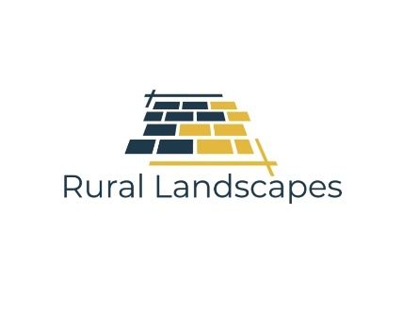

Bespoke Driveways
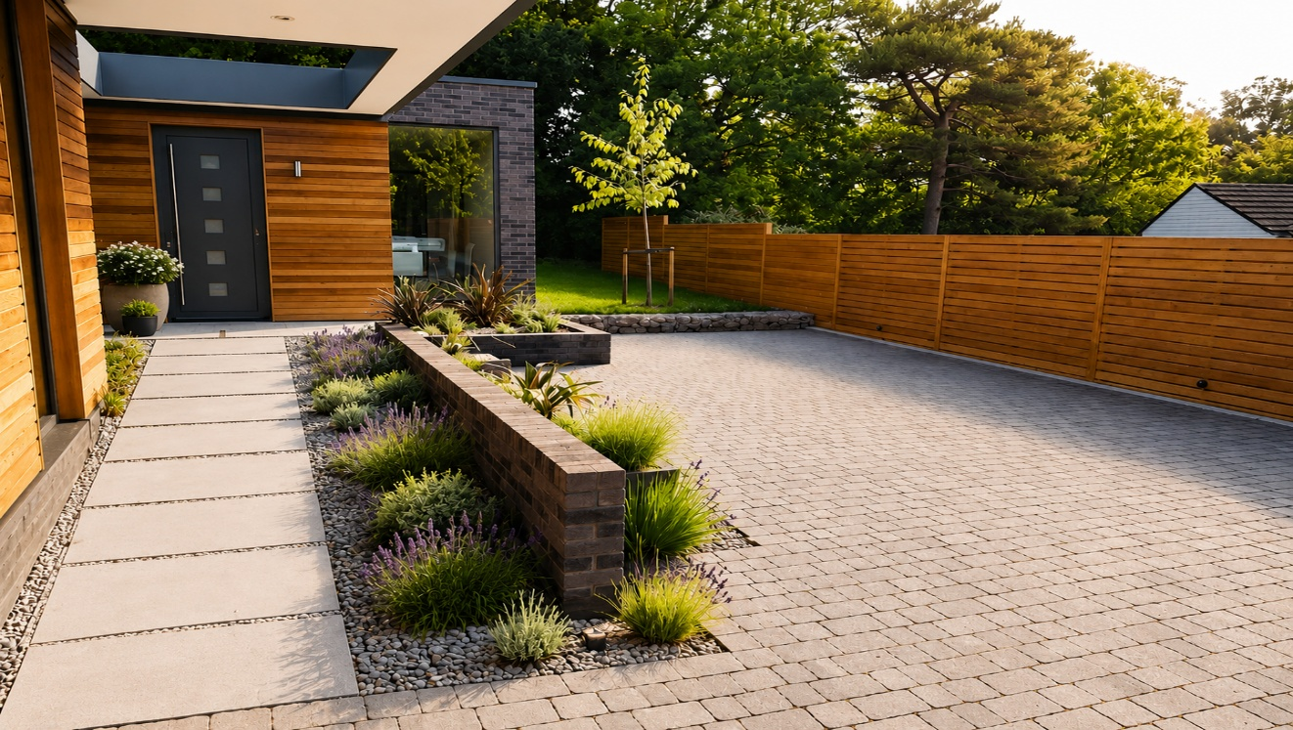

Designed • Built • Installed

A professionally installed driveway is more than just a place to park your car. It's the first impression of your home, adding kerb appeal, improving practicality and increasing property value.
At RuralLandscapes Ltd, we design and install high-quality driveways using premium materials and expert workmanship. Whether you prefer the timeless appearance of block paving, the contemporary finish of resin bound, or the natural charm of gravel or stone setts, we'll create a driveway that's built to last.
Premium Materials • Expert Craftsmanship • Built for Everyday Use
FREE Site Survey & Written Quotation

FIRST IMPRESSIONS START AT THE DRIVEWAY

Transform the Front of Your Home
Your driveway is one of the first things people notice when they arrive at your property. A professionally designed and installed driveway not only enhances the appearance of your home but also provides a safe, practical and durable surface for everyday use.
At RuralLandscapes Ltd, we create bespoke driveways that combine outstanding workmanship with premium materials. Every driveway is carefully designed to complement your home while providing long-lasting performance in all weather conditions.
Whether you're replacing an old, worn-out driveway or creating a brand-new entrance, we'll help you choose the right materials, layout and finish to suit your property and budget.
From the initial consultation to the final clean-up, we take pride in delivering a professional service, attention to detail and workmanship that stands the test of time

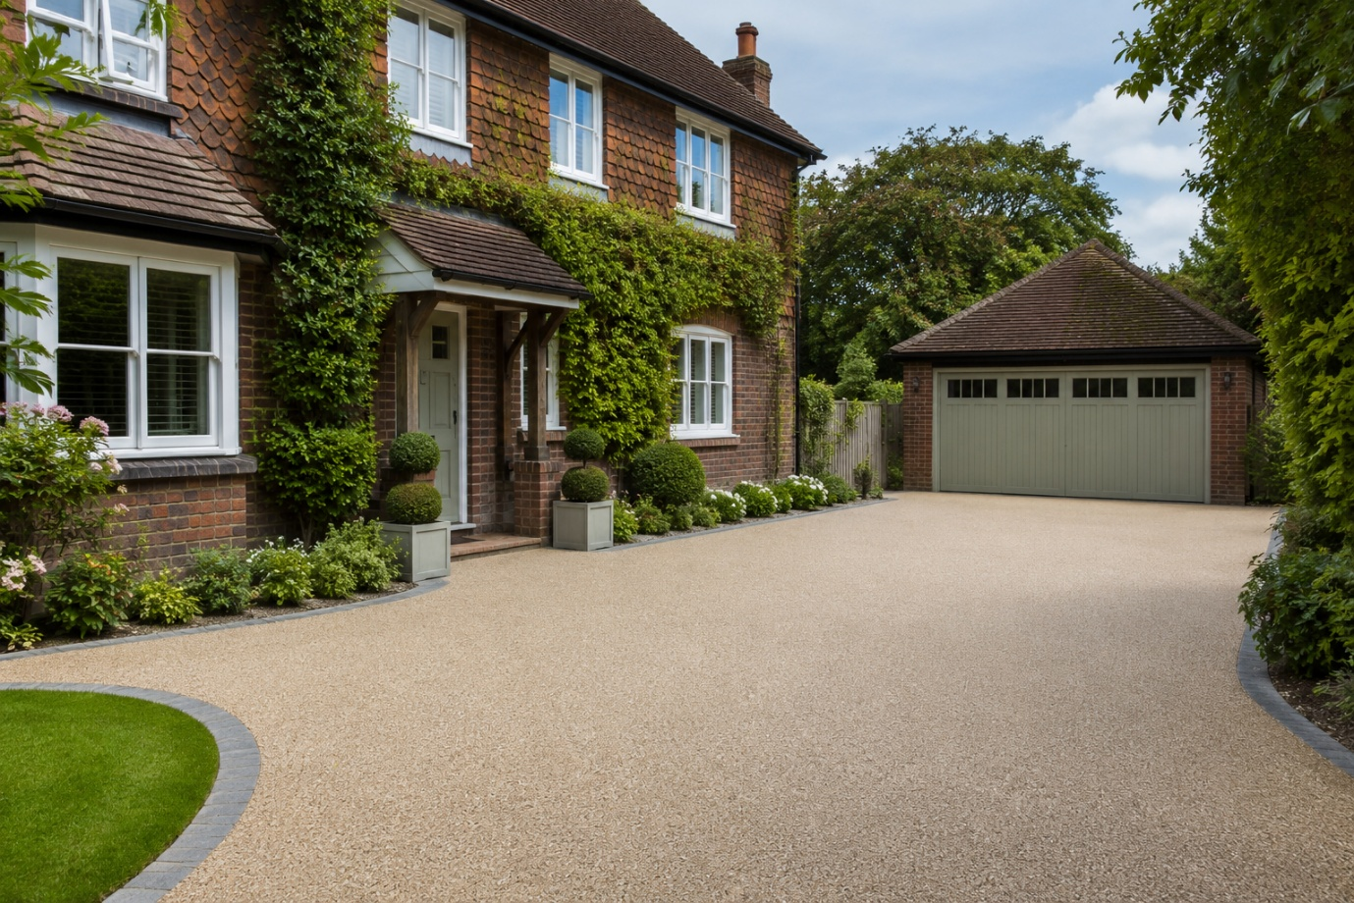

CHOOSING THE RIGHT DRIVEWAY

A Driveway Designed Around Your Home
Every property is different, which is why we offer a range of driveway solutions to suit every style and budget.

Block Paving
One of the UK's most popular driveway choices. Available in a wide range of colours, sizes and laying patterns, block paving is durable, attractive and easy to repair if required.

Resin Bound Driveways
A smooth, modern surface that's permeable, low maintenance and available in a wide variety of natural stone colours. Resin bound driveways create a clean, contemporary finish that's ideal for modern and traditional homes alike.

Gravel Driveways
A cost-effective option that offers excellent drainage and timeless character. Decorative gravel is available in a range of colours and stone sizes to complement any property.

Natural Stone Setts
Perfect for creating a premium, traditional appearance. Granite and natural stone setts provide exceptional durability while adding character and elegance to your home's entrance.

Permeable Driveways
Designed to allow surface water to drain naturally, permeable systems can help reduce standing water while complying with modern drainage requirements.
Whatever your preference, we'll help you choose a driveway that enhances the appearance of your property and provides years of reliable performance

DESIGNED AROUND YOUR HOME

Every Driveway Is Individually Designed
No two homes are the same, and neither are our driveways. Every project is designed to complement your property's style while meeting your practical requirements.
From traditional country homes to modern developments, we'll create a driveway that's both functional and visually impressive.

Colours & Finishes
Choose from a wide range of colours, textures and materials to complement your home's architecture and landscaping.

Borders & Edging
Add definition and character with contrasting borders, kerb stones, granite setts or decorative edging.

Laying Patterns
Block paving can be laid in a variety of attractive patterns, including Herringbone, Stretcher Bond and Basket Weave, creating a truly bespoke finish.

Drainage Solutions
Effective drainage is essential for every driveway. We incorporate suitable drainage systems where required, helping to prevent standing water and protect your investment.

Paths & Entrance Features
Complete the look with matching pathways, steps, entrance features and landscaping, creating a seamless finish from the roadside to your front door.
Every detail is carefully considered to ensure your new driveway enhances the appearance, functionality and value of your home

HOW WE BUILD YOUR DRIVEWAY

Built to Last from the Ground Up
A great driveway isn't just about the finished surface—it's what's underneath that really matters. At RuralLandscapes Ltd, we never cut corners. Every driveway is built using the correct groundwork and installation methods to ensure strength, durability and long-term performance.
From the initial excavation through to the final finishing touches, every stage is completed with care and attention to detail.

Free Consultation
Every project begins with a free, no-obligation consultation where we'll discuss your ideas, assess your property and recommend the most suitable driveway solution for your home.

Site Survey
Before work begins, we carry out a detailed survey to assess access, drainage, ground conditions and levels, allowing us to plan the installation correctly from the outset.

Excavation & Preparation
The existing driveway or surface is carefully removed, and the area is excavated to the required depth. All waste materials are responsibly removed from site.

Sub-Base Installation
A high-quality MOT Type 1 sub-base is installed and compacted in layers to create a strong, stable foundation capable of supporting vehicles for many years.

Drainage Installation
Where required, drainage channels and soakaway systems are installed to ensure rainwater is managed correctly and complies with current regulations.

Surface Installation
Your chosen driveway material is professionally installed using proven techniques to achieve a precise finish that's both attractive and durable.

Final Inspection
Before handover, every driveway is thoroughly inspected to ensure it meets our high standards of workmanship. The site is left clean and tidy, ready for you to enjoy

MATERIALS & SPECIFICATION

Quality Materials Make the Difference
At Rural Landscapes Ltd, we believe that using premium materials is essential for creating a driveway that not only looks fantastic but also performs for many years to come.
Every installation is completed using carefully selected products from trusted suppliers, ensuring exceptional durability, strength and long-lasting appearance.

Our Standard Specification Includes
- Professional site preparation
- Full excavation to the correct depth
- MOT Type 1 compacted sub-base
- Geotextile membrane where required
- Quality edge restraints
- Suitable drainage systems
- Premium paving materials
- Kiln-dried jointing sand (for block paving)
- Professional compaction and finishing
- Complete site clean-up

Finishing Options
Personalise your driveway with:
- Contrasting borders
- Granite edging
- Decorative kerbs
- Drainage channels
- Matching pathways
- Entrance steps
- Feature lighting
- Front garden landscaping

OUR INSTALLATION PROCESS

A Professional Service from Start to Finish
We believe every customer deserves a smooth, straightforward experience. That's why we manage every stage of your driveway installation with clear communication and professional workmanship.

Step 1 – Free Consultation
We'll visit your property, discuss your ideas and recommend the most suitable driveway for your home and budget.

Step 2 – Site Survey
Accurate measurements are taken, ground conditions are assessed and drainage requirements are carefully considered before work begins.

Step 3 – Design & Written Quotation
You'll receive a detailed quotation outlining the proposed work, materials and costs with no hidden surprises.

Step 4 – Professional Installation
Our experienced team carries out every stage of the installation, from excavation and groundwork through to laying the finished surface.

Step 5 – Final Inspection
Every detail is checked to ensure your driveway meets our high standards before completion.

Step 6 – Completion & Handover
Your new driveway is cleaned, inspected and ready to use. We'll make sure you're completely satisfied before we leave.
At Rural Landscapes Ltd, our commitment to quality workmanship and customer satisfaction is at the heart of every project

GUIDE PRICES

Honest Pricing. Exceptional Value.
Every driveway is individually designed and priced to suit your property and requirements. The final cost will depend on the size of the area, the materials selected, site access, drainage requirements and the amount of groundwork involved.
Below are typical guide prices to help you plan your project.

Block Paving
From £110–£180 per m²
A durable, versatile option available in a wide range of colours and patterns.

Resin Bound Driveways
From £150–£220 per m²
A smooth, modern finish that's permeable, attractive and low maintenance.

Decorative Gravel
From £60–£100 per m²
A cost-effective solution with excellent drainage and a traditional appearance.

Natural Stone Setts
From £140–£220 per m²
A premium driveway option offering timeless character and outstanding durability.

What's Included?
Our quotations typically include:
- Free consultation and site survey
- Excavation and waste removal
- MOT Type 1 sub-base
- Drainage where required
- Edge restraints
- Surface installation
- Professional finishing
- Final inspection
- Site clean-up
Every quotation is individually prepared, giving you complete clarity on costs before any work begins. No hidden charges—just quality workmanship and honest pricing

Enhance safety and kerb appeal with modern driveway lighting, pathway lights or feature lighting to create a welcoming entrance after dark.

Entrance Features
Complete your property's entrance with decorative kerbs, edging, planting areas or bespoke entrance pillars for a premium finish.

OPTIONAL EXTRAS

Complete Your Driveway with the Perfect Finishing Touches
A driveway is more than just somewhere to park your car. The right finishing touches can enhance the appearance of your property, improve functionality and create a welcoming entrance to your home.
At Rural Landscapes Ltd, we offer a range of optional extras to personalise your driveway and complete the overall look of your outdoor space.

Decorative Borders
Add contrast and definition with complementary block paving, granite setts or natural stone edging to create a bespoke finish.

Pathways & Entrance Paths
Create a seamless connection between your driveway and front door with matching pathways that complement your chosen driveway material.

Steps & Raised Areas
Where your property has varying levels, we can construct attractive steps and raised features that blend perfectly with your new driveway.

Drainage Systems
Effective drainage is essential. We install discreet drainage channels and soakaways where required to prevent standing water and protect your investment.

Lighting
Enhance safety and kerb appeal with modern driveway lighting, pathway lights or feature lighting to create a welcoming entrance after dark.

Entrance Features
Complete your property's entrance with decorative kerbs, edging, planting areas or bespoke entrance pillars for a premium finish.

Landscaping
As landscaping specialists, we can transform the surrounding areas with new lawns, planting, fencing, patios and borders to complement your new driveway.
Every driveway is individually designed, ensuring the finished result perfectly suits your property and enhances its overall appearance
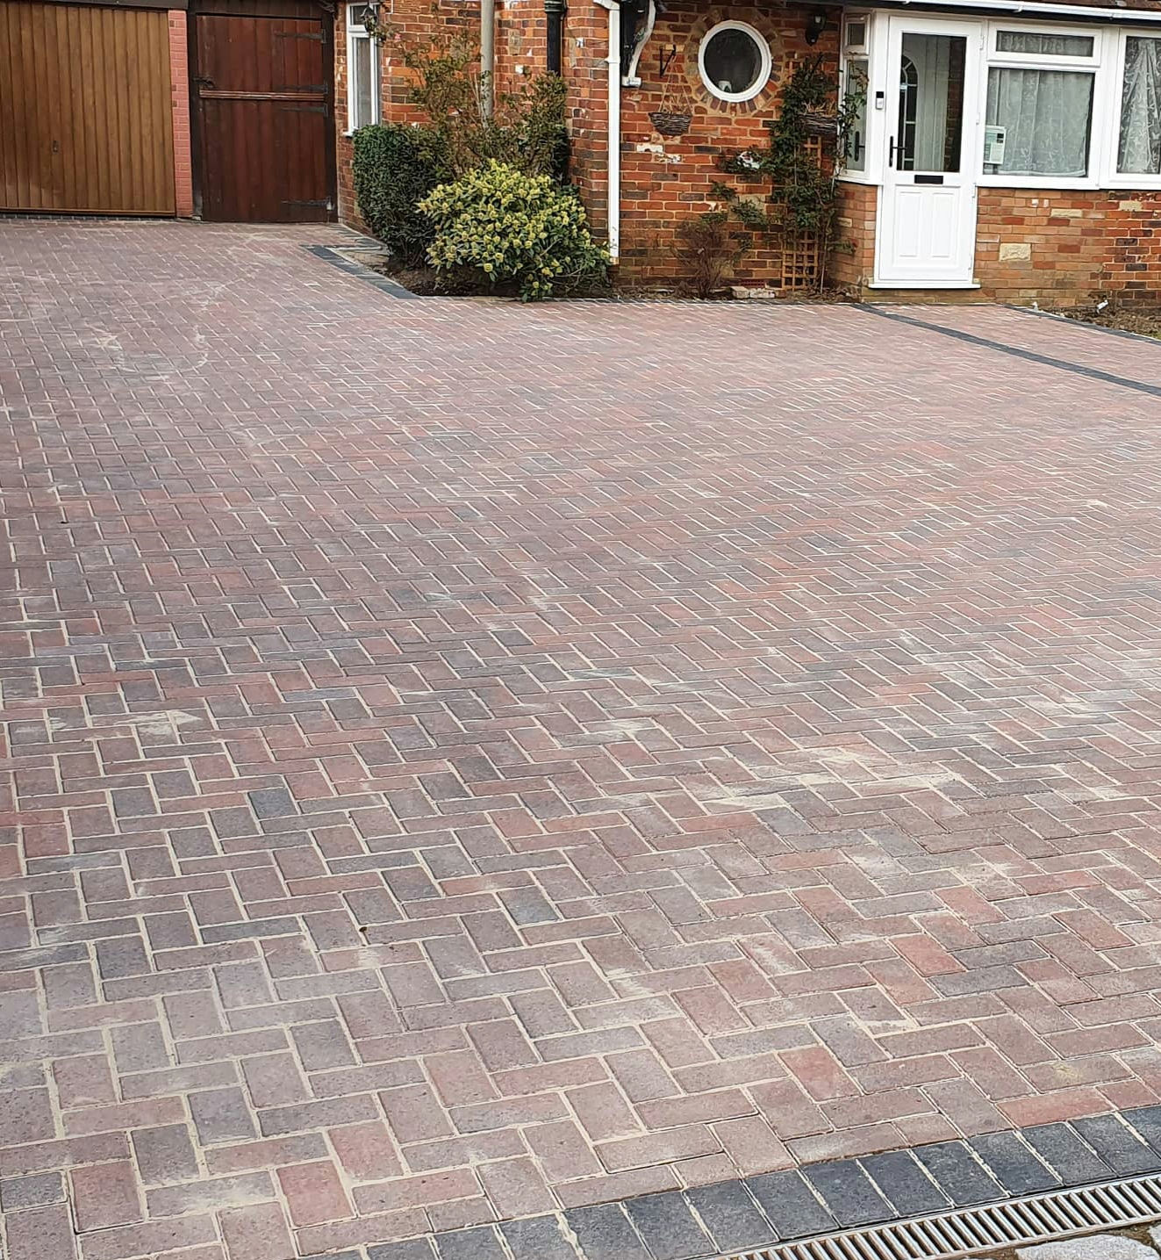

FREQUENTLY ASKED QUESTIONS

Everything You Need to Know

How long will my new driveway last?
A professionally installed driveway can last for decades when constructed correctly using quality materials and maintained properly.

How long does installation take?
Most driveways are completed within 3–7 days, depending on the size of the project, ground conditions and the chosen surface.

Will weeds grow through my driveway?
Modern installation methods greatly reduce weed growth. Occasional maintenance may still be required around joints or edges, but regular sweeping and cleaning will keep your driveway looking its best.

Do you install drainage?
Yes. We assess drainage during every site survey and install suitable drainage systems where required to comply with current regulations.

Can I choose different colours and patterns?
Absolutely. We offer a wide range of colours, laying patterns and border options to create a driveway that's unique to your property.

Will my driveway add value to my home?
A professionally installed driveway can significantly improve kerb appeal and may increase the attractiveness and value of your property.

How much does a driveway cost?
The cost depends on the size, materials and amount of groundwork required. We provide free, no-obligation quotations with clear pricing and no hidden costs.

Do you offer a guarantee?
Yes. We stand behind the quality of our workmanship and use carefully selected materials designed to provide long-lasting performance.
If you have any further questions, we're always happy to help

Why Choose RuralLandscapes LTD?

Quality Workmanship from a Company You Can Trust
Choosing the right contractor is just as important as choosing the right driveway. At Rural Landscapes Ltd, we combine quality materials, expert workmanship and honest advice to deliver driveways that are built to last.
From small private driveways to larger residential projects, we approach every installation with the same commitment to quality and attention to detail.

Why Homeowners Choose Us
✔ Bespoke Driveway Designs
✔ Premium Quality Materials
✔ Correct Excavation & Ground Preparation
✔ Proper MOT Type 1 Foundations
✔ Professional Drainage Solutions
✔ Skilled & Experienced Installation
✔ Honest, Transparent Pricing
✔ Clean & Tidy Workmanship
✔ Reliable & Friendly Service
✔ Free Site Survey & Written Quotation
We don't believe in shortcuts. Every driveway is constructed using proven methods and quality materials, ensuring a finish that's attractive, durable and built to withstand years of everyday use.
Our reputation has been built on reliability, craftsmanship and customer satisfaction, and we're proud to help homeowners transform the appearance of their properties

CONTACT US

Ready to Transform Your Driveway?
Whether you're replacing an existing driveway or creating a brand-new entrance to your home, RuralLandscapes Ltd is here to help.
From your initial enquiry through to the completed installation, we'll provide honest advice, expert workmanship and a professional service you can rely on.
If you're ready to improve the appearance, practicality and value of your property, we'd love to hear from you.

Book Your FREE Site Survey & Written Quotation
There's no obligation—just friendly, professional advice and a detailed quotation tailored to your property and requirements.

Contact RuralLandscapes Ltd
📞 Telephone – 07881 203 957

✉️ Email - rl-ltd@hotmail.co.uk

🌐 Website – www.rl-ltd.co.uk

